Our school administers the Kansas Communities That Care (KCTC) Student Survey to
6th, 8th, 10th, and 12th grade students. We hope you allow your child to participate.

About the Survey

- This valuable tool helps us understand challenges students face, and how they behave, feel, and think about problem behaviors, like substance use.
- Student insight helps inform prevention program planning and applications for grants designed to help students succeed.
- It is completely anonymous. Students aren’t asked for any information that could identify them.  - It is voluntary. Your child may decline to participate in the survey or skip questions they don’t want to answer.  - Annual participation is important, as it helps determine effectiveness of previous efforts and inform program changes.  - View the survey at kctcdata.org/studentsurvey. Contact Principal <<INSERT NAME>> at <<INSERT CONTACT INFO>> to learn which survey questions our district will administer. | 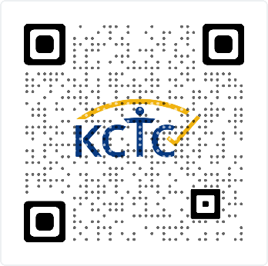  View Guardian Informed Consent  kctcdata.org/guardian-informed-consent

THANK YOU FOR RETURNING THE FORM BELOW BY <<insert date>>.

1. CHECK ONE

- YES, I give permission for my child to participate in the KCTC Student Survey.

- NO, I do not give permission for my child to participate in the KCTC Student Survey.

2. SIGN HERE

Guardian Signature Print Guardian Name

Print Child Name Date

